Food Drive
Coordinators
Manual

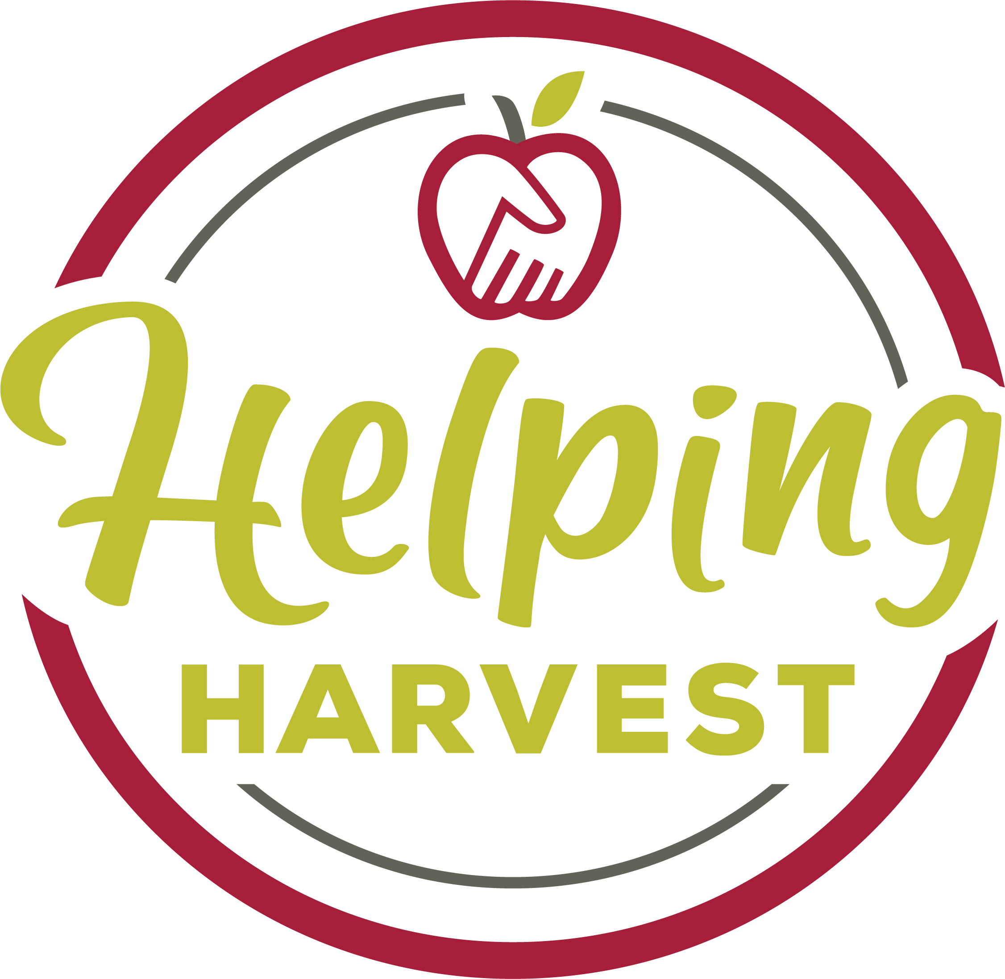

117 Morgan Drive, Reading, PA 19608 · (610) 926-5802

CONDUCTING A FOOD DRIVE
FOR HELPING HARVEST

Thank you for your interest in conducting a food drive for Helping Harvest. Review the attached a list of suggested items for collection. You may wish to photocopy or post this list so others are aware of the items in need.

When collecting food items, keep the following requirements in mind:

- Please do not donate out-of-date food or food in rusted, dented, or leaking cans or containers.
- If an outer box is torn, but the inner wrapping is still sealed, we can still use the item.
- All food items must include the product name. No unidentifiable bags or cans can be used.
- Non-perishable food in plastic, cardboard or cans works best. Glass can easily be broken.
- Home-made items (canned jellies, sauces, etc.) and perishable items can not be accepted.

Please feel free to call us at 610-926-5802 X 228 if you need more information.

117 Morgan Drive, Reading, PA 19608 · (610) 926-5802
Food Drive for
Helping Harvest

RECOMMENDED ITEMS FOR COLLECTION

Non-perishable food items
- cereals
- peanut butter
- grains (rice, oatmeal etc.)
- dry milk
- pasta
- snack items (crackers, fruit snacks, cookies)
- beans
- fruit juices
- canned goods:
  - tuna fish
  - meats (chili, stew, etc.)
  - fruits
  - vegetables
  - soups
Baby items
baby shampoo diapers
baby wipes baby lotion
Personal hygiene items
shampoo bath soap
toothpaste toothbrushes

Donate through the QR code, or visit Helpingharvest.org for more information.


Getting Started

While the way you decide to run your food drive is completely up to you, most coordinators follow these basic steps:

1. Decide on the dates, locations, and supplies needed for your drive.
2. Notify Helping Harvest of your food drive.
3. Promote your drive to its participants.
4. Start collecting food and money!
5. At the end of your drive, the Food Bank will weigh your donations and send you a statement reporting how much was collected.
6. Celebrate the success of your food drive!

Planning Your Drive
Some of the most important work done during your food drive actually happens before it even begins. Planning ahead will make your campaign far more successful and can also save you a lot of time and energy.

Selecting Dates
First, you should decide on dates for your drive. Food drives can run for as little as an hour or for up to two months. Some donors even collect donations year-round. The average drive is usually about 2 to 3 weeks. This is a good time period to begin with if you are unsure.

Setting a Goal
Setting a goal is a good way to motivate your donors and provide a sense of accomplishment at the end of your drive. Your goal could be a total number of pounds or dollars you would like to collect or to collect a certain number of pounds per person. You could also set a physical goal, such as filling a certain number of boxes or filling an area, such as an office, with food.

Choosing Your Locations
Next you should decide where you are going to have your food drive. If you have multiple locations, you may want to recruit someone at each of those sites to help you manage donations at each building. Select high-traffic areas where the containers will be noticeable and convenient for donors to access. If you have facilities staff, ask them about a good location and see if they are willing to help maintain the areas where donations will be collected. Be sure to consider safety and security issues when choosing your locations.

Making Financial Donations

The most successful food drives have a financial element. It may be easier for an employee to write a check than to purchase a bag of groceries. It may be more fun to participate in a bake sale fundraiser than to go to the supermarket during the holidays.

Cash donations are always welcome and provide an even greater supply of food, due to our ability to purchase food in bulk.

For example, you could go to the grocery store and buy a box of name brand cereal for about $3, or you could donate the $3 to Helping Harvest to help pay our transportation cost for donated foods. Using a recent example - it cost Helping Harvest $345 to transport in 19,392 boxes of cereal (some 11 oz. and some 6.4 oz.)—that’s less than 2 cents per box. So theoretically, the $3 donation would pay for the shipping of 150 boxes of cereal.

Donations can be dropped off in person, mailed, or donated via our website, www.helpingharvest.org. The Food Bank accepts cash, checks and credit cards. Credit card donations can be made through the website, or by scanning the QR code below. In order to ensure that your food drive receives credit for the donation, please be sure to designate it as part of your organization’s food drive when making the donation.

Ordering and distributing our donation envelopes is also an excellent way to encourage financial contributions. Envelopes can either be mailed individually to the Food Bank or collected by your onsite Food Drive Coordinator and delivered together.

Seven Ways to Encourage Financial Contributions:

1. Allow employees to donate the cash value of vacation days.
2. Set up change collection containers in the cafeteria.
3. Hold a raffle with fun prizes like the CEO or Principal as the winner’s assistant for the day.
4. Have a party or event and donate the admission to the Food Bank.
5. Hold an auction with creative prizes. At one live auction, the CEO sold the shirt off his back!
6. Sell treats, such as baked goods, sandwiches, or coffee drinks with management as the chefs.

117 Morgan Drive, Reading, PA 19608 · (610) 926-5802

Let Us Know About Your Food Drive

Let us know about your food drive by mailing or faxing us this form or by e-mailing the information
to marketing@helpingharvest.org.

Company/Organization Name: _____________________________________________________

Contact Name: _________________________________________________________________

Address: ______________________________________________________________________

Phone: _______________________________ Fax: ___________________________________

E-mail: _______________________________________________________________________

Dates of Food Drive: ____________________________________________________________

____ Please send us ____ food drive posters to display. The poster lists recommended items.

____ Please send us ____ copies of your latest newsletter.

____ Please send us ____ contribution envelopes.

Comments:

Getting Donations to Helping Harvest

Food and cash donations can be dropped off at Helping Harvest on Mondays through Fridays from 8:00 a.m. to 4:00 p.m.

Donation Drop Off

- Helping Harvest is located on 117 Morgan Dr., Reading 19608
- Food donations are accepted between 9am and 3pm, Monday through Friday
- All donations can be taken to the door to the left of the loading docks. The door is labeled “Donation drop-off” and has a red awning
- Enter through this door and ring the doorbell inside
- A warehouse staff member will meet you and collect your donations
- You can ask for a weight receipt when you drop off your donation. If you provide the relevant information, you will also receive an acknowledgment letter with the weight in the mail.
- If your donation exceeds 500 pounds (500 items) HH can provide pick-up service, however, we encourage drop-offs as much as possible. Please call 610-926-5802 x205 to schedule a pickup if your food drive meets this criterion.

.

117 Morgan Drive, Reading, PA 19608 · (610) 926-5802
Place Your Donations Here

610-926-5802 helpingharvest.org

