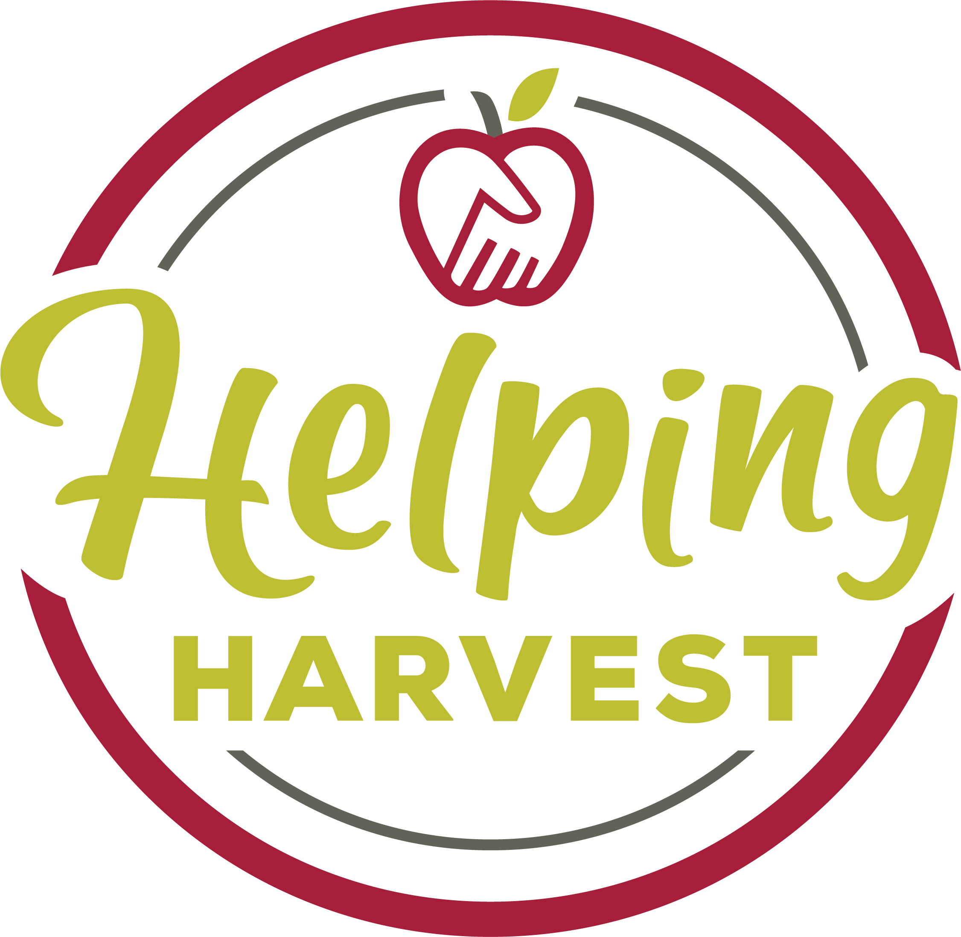

HELPING HARVEST
Pantry Recipient Form

Program Month/Year: _________________
Completed By: _________________________________ Phone Number:_______________

TOTAL HOUSEHOLD INCOME FFY 2022-2023 I the undersigned recipient understand the total
FAMILY SIZE ANNUAL MONTHLY WEEKLY household income limitations or have had them
1 $25,142 $2,095 $484 explained to me. I hereby certify that my house-
2 33,874 2,823 651 hold size is as specified and I am therefore income
3 42,606 3,551 819 eligible for participation in the program. The
4 51,338 4,278 987 TEFAP program and State Grant Purchase program
5 60,070 5,006 1,155 is operated in accordance with the U.S. Department
6 68,802 5,734 1,323 of Agriculture policy, which prohibits discrimina-
7 77,534 6,461 1,491 tion on the basis of race, color, national origin,
8 86,266 7,189 1,659 gender, religion, age disability, political beliefs,

Each Additional Add: $ 8,732 $ 728 $168 sexual orientation, and marital or family status.

Print Name | Child  0-17 | Adult  18-59 | Elderly  60+ 60+ | Total  H-H | Recipient's Signature | New
1.
2.
3.
4.
5.
6.
7.
8.
9.
10.
Total: |  |  |  |  | Total Households:( ) New:

- Print recipient’s name and document age(s) of each individual living in the household.
- Ask the recipient to look at the income guidelines and then sign his/her name certifying that they are income eligible and the total # living in the household is correct.
- If this is the first time the recipient has come to your pantry, place a “Y” beside their signature under “New”.
- Calculate the totals at the bottom of each page by adding the number of children, adults, and elderly living in the household. Count the signatures to document the number of households served. Total the “New” check marks.
- Total all the recipient pages together and write these totals on the “Monthly Statistics Report” which is to be attached to the front of your recipient forms.
Mail or email by the FIFTH of the current month for the previous month's distribution to:
Alexis Fick: afick@helpingharvest.org

Helping Harvest - 117 Morgan Drive - Reading, PA 19608
Failure to turn in this form by the FIFTH of the month following the previous month’s distribution may jeopardize future food orders for your program. Even if no clients are served during the month, you must submit this report stating "no one served this month"

