**Food Drive Coordinator’s Manual**

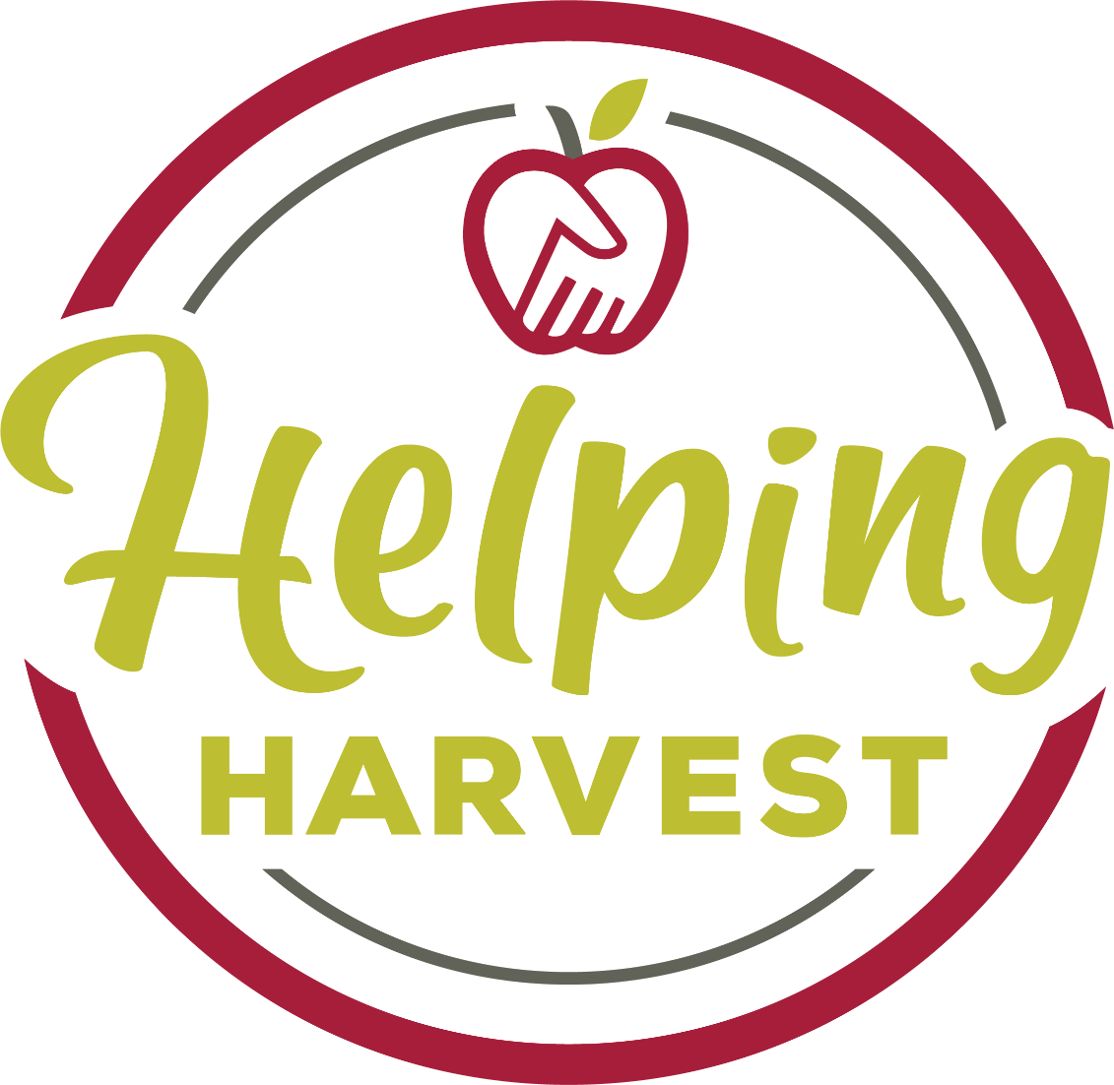

How to Run a Food Drive

1. Decide on your food drive timeline
2. If you would like food drive posters, contribution envelopes, or newsletters to support your food drive, please complete the *“Let us know about your food drive”* form and fax or email to gbfbmarketing@feedingamerica.org
3. Collect nonperishable foods and/or funds *($1 = $20 worth of food)*
4. Deliver donations to Helping Harvest any weekday between 8:30 and 3:30

(no need to call ahead)

Donation Drop Off

1. Helping Harvest is located on 117 Morgan Dr., Reading 19608
2. All donations can be taken to the door to the left of the loading docks

(The door is labeled “Donation drop-off” and has a green awning)

1. Enter through this door and ring the doorbell just inside the door
2. A warehouse staff member will meet you and collect your donations
3. You can ask for a weight receipt when you drop off your donation. You will also receive an acknowledgment letter with the weight in the mail.
4. If your donation exceeds 500 pounds (500 items) HH can provide pick-up service, however, we encourage drop-offs as much as possible.

Food Drive FAQ

1. Who can host a food drive?

Anyone! Individuals, clubs and organizations, businesses, churches, etc…

1. How long should my food drive last?

Your food drive can go for any amount of time (1 hour - 2 months)

1. How can I promote my food drive?

We are happy to supply you with posters, newsletters, and contribution envelopes by filling out and sending in the “Let us know about your food drive” form. Feel free to get creative as well!

1. Must I pack donations in any specific way?

Nope! We just ask that you pack the food as neatly as possible (especially being mindful of glass jars).

1. Do you provide bins for the food drive?

We do not. We encourage you to use any form of bin or box you choose. Once the collection is complete, you can transport your donations in your collection boxes and take your bins back the same day.

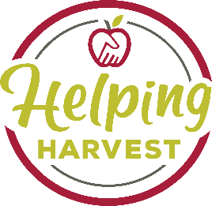Let Us Know About Your Food Drive

Let us know about your food drive by mailing or faxing us this form or by e-mailing the information to marketing@helpingharvest.org

Company/Organization Name:

_______________________________________________________________

Contact Name:

________________________________________________________________

Address:

________________________________________________________________

Phone:

________________________________________________________________

E-mail:

________________________________________________________________

Dates of Food Drive:

________________________________________________________________

Please send us:

____ Copies of your latest newsletter

____ Contribution envelopes

____ Food drive posters

Comments: