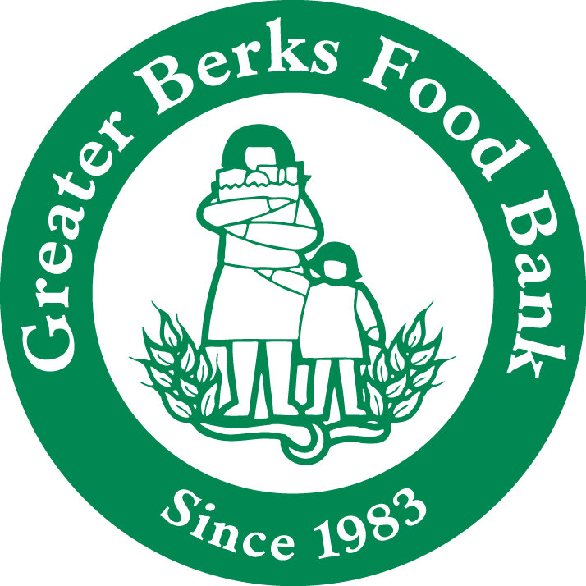 GREATER BERKS FOOD BANK
Pantry Recipient Form

Program Month/Year: ____________________
Completed By: __________________________________________ Phone Number: ___________________

TOTAL HOUSEHOLD INCOME FFY 2016-2017 I the undersigned recipient understand the total
FAMILY SIZE ANNUAL MONTHLY WEEKLY household income limitations or have had them
1 $17,820 $1,485 $343 explained to me. I hereby certify that my house-
2 24,030 2,003 462 hold size is as specified and I am therefore income
3 30,240 2,520 582 eligible for participation in the program. The
4 36,450 3,038 701 TEFAP program and State Grant Purchase program
5 42,660 3,555 820 is operated in accordance with the U.S. Department
6 48,870 4,073 940 of Agriculture policy, which prohibits discrimina-
7 55,095 4,591 1,060 tion on the basis of race, color, national origin,
8 61,335 5,111 1,180 gender, religion, age disability, political beliefs,

Each Additional Add: $ 6,240 $ 520 $120 sexual orientation, and marital or family status.

Print Name | Child  0-17 | Adult  18-59 | Elderly  60+ 60+ | Total  H-H | Recipient's Signature | New
1. |  |  |  |  | 1.
2. |  |  |  |  | 2.
3. |  |  |  |  | 3.
4. |  |  |  |  | 4.
5. |  |  |  |  | 5.
6. |  |  |  |  | 6.
7. |  |  |  |  | 7.
8. |  |  |  |  | 8.
9. |  |  |  |  | 9.
10. |  |  |  |  | 10.
Total: |  |  |  |  | Total Households:( ) New:

- Print recipient’s name and document age(s) of each individual living in the household.
- Ask the recipient to look at the income guidelines and then sign his/her name certifying that they are income eligible and the total # living in the household is correct.
- If this is the first time the recipient has come to your pantry, place a “Y” beside their signature under “New”.
- Calculate the totals at the bottom of each page by adding the number of children, adults, and elderly living in the household. Count the signatures to document the number of households served. Total the “New” check marks.
- Total all the recipient pages together and write these totals on the “Monthly Statistics Report” which is to be attached to the front of your recipient forms.
Mail or fax by the FIFTH of the current month for the previous month's distribution to:

Greater Berks Food Bank - 117 Morgan Drive - Reading, PA 19608

Fax: 610-926-7638
Failure to turn in this form by the FIFTH of the month following the previous month’s distribution may jeopardize future food orders for your program. Even if nobody is served during the month, you must submit this report stating "nobody served this month".

